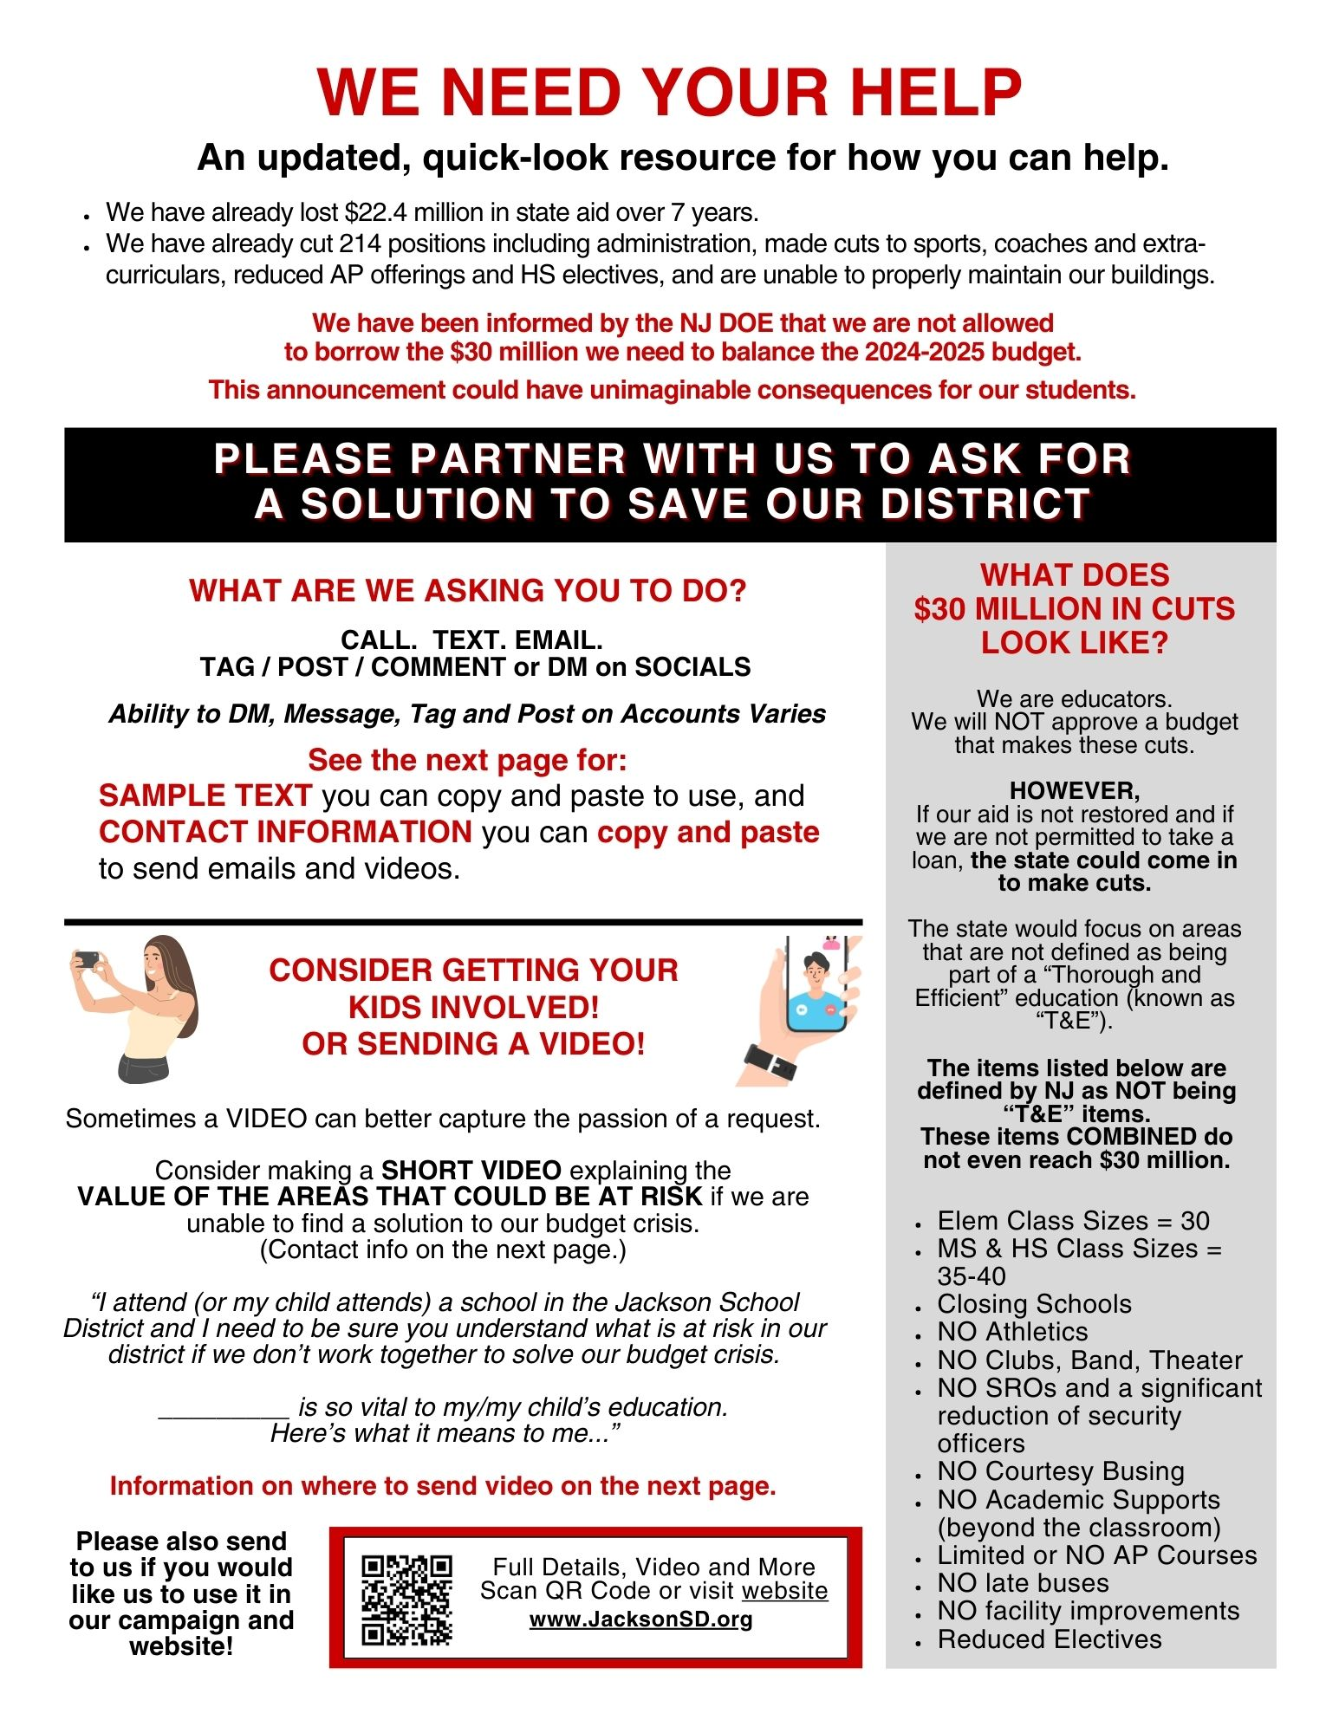

**I WANT TO HELP BUT WHAT DO I SAY? WHOM DO I CALL OR EMAIL?**

We’ve heard from parents, staff and residents who were looking for a quick resource to use to help the Jackson School District secure the funds we need to support our district for next year.

This information and even more details about our budget crisis and advocacy are available on our [**Budget and Financial Information Page**](https://www.jacksonsd.org/domain/200) **- but this document contains a quick-look resource with a SAMPLE LETTER and CONTACT INFORMATION you can use to copy and paste if you wish**.

|  |  |  |
| --- | --- | --- |
| **INFORMATION YOU CAN USE**  **FEEL FREE TO COPY and PASTE**  **OR WRITE YOUR OWN!**  I am imploring you to advocate for the students of the Jackson School District, who have lost $22.4 million in state aid over the past seven years. Our district also just learned that all districts will not be permitted to ask for any loans to help balance our budgets for the 2024-2025 school year.  This will have unimaginable consequences for the Jackson School District. Our district has already cut 214 positions including administration, made cuts to sports, coaches and extra-curriculars, reduced AP offerings and HS electives, and are unable to properly maintain our buildings. The Tentative Budget introduced in March 2024 was based on the hope that we could secure a $30 million loan to be able to support our students.  **If we aren’t going to have our aid restored, we at least need the ability to borrow this $30 million to support our students.** We have lost so much already and we cannot withstand $30 million more in budget cuts.  We are fiscally sound. We do not have a spending problem - we have a REVENUE problem. Why should our students have fewer programs, services, athletics, co-curriculars and opportunities?  **I respectfully ask that you save us from the fiscal cliff we are about to go over.**  Please consider visiting the [Jackson School District Budget and Financial Page](https://www.jacksonsd.org/domain/200) to learn more about our unique situation. | **EMAIL ADDRESSES**  **Copy and Paste**  **Governor Murphy and the Senate and Assembly Budget and Education Committees**  [constituent.relations@nj.gov](mailto:constituent.relations@nj.gov)  [SenAmato@njleg.org](mailto:SenAmato@njleg.org)  [SenBurgess@njleg.org](mailto:SenBurgess@njleg.org)  [Senburzichelli@njleg.org](mailto:Senburzichelli@njleg.org)  [SenCruzperez@njleg.org](mailto:SenCruzperez@njleg.org)  [SenDiegnan@njleg.org](mailto:SenDiegnan@njleg.org)  [SenJohnson@njleg.org](mailto:SenJohnson@njleg.org)  [SenOscanlon@njleg.org](mailto:SenOscanlon@njleg.org)  [SenRuiz@njleg.org](mailto:SenRuiz@njleg.org)  [SenSteinhardt@njleg.org](mailto:SenSteinhardt@njleg.org)  [SenTesta@njleg.org](mailto:SenTesta@njleg.org)  [SenZwicker@njleg.org](mailto:SenZwicker@njleg.org)  [SenGopal@njleg.org](mailto:SenGopal@njleg.org)  [SenTurner@njleg.org](mailto:SenTurner@njleg.org)  [SenCorrado@njleg.org](mailto:SenCorrado@njleg.org)  [SenHenry@njleg.org](mailto:SenHenry@njleg.org)  [SenMcknight@njleg.org](mailto:SenMcknight@njleg.org)  [AswPintorMarin@njleg.org](mailto:AswPintorMarin@njleg.org)  [AsmBarlas@njleg.org](mailto:AsmBarlas@njleg.org)  [AsmConaway@njleg.org](mailto:AsmConaway@njleg.org)  [AswDunn@njleg.org](mailto:AswDunn@njleg.org)  [AsmFrieman@njleg.org](mailto:AsmFrieman@njleg.org)  [AswMurphy@njleg.org](mailto:AswMurphy@njleg.org)  [AswPark@njleg.org](mailto:AswPark@njleg.org)  [AswReynoldsJackson@njleg.org](mailto:AswReynoldsJackson@njleg.org)  [AsmRodriguez@njleg.org](mailto:AsmRodriguez@njleg.org)  [AsmRumpf@njleg.org](mailto:AsmRumpf@njleg.org)  [AsmScharfenberger@njleg.org](mailto:AsmScharfenberger@njleg.org)  [AsmVenezia@njleg.org](mailto:AsmVenezia@njleg.org)  [AswLampitt@njleg.org](mailto:AswLampitt@njleg.org)  [AsmStanley@njleg.org](mailto:AsmStanley@njleg.org)  [AswBagolie@njleg.org](mailto:AswBagolie@njleg.org)  [AswFantasia@njleg.org](mailto:AswFantasia@njleg.org)  [AswMatsikoudis@njleg.org](mailto:AswMatsikoudis@njleg.org)  [AswMorales@njleg.org](mailto:AswMorales@njleg.org)  [AsmSchnall@njleg.org](mailto:AsmSchnall@njleg.org)  [AsmSimonsen@njleg.org](mailto:AsmSimonsen@njleg.org)  [AswSwain@njleg.org](mailto:AswSwain@njleg.org) | **CONTACT INFO**  **To CALL or TEXT**  **or TAG / POST / COMMENT**  **or DM on SOCIALS**  **NOTE:**  **Ability to DM, Message, Tag and Post Varies by Account**  **Governor Phil Murphy**  **TEXT:**  732-605-5455  **CALL:** 609-292-6000  **X & Instagram:** @GovMurphy  **Facebook:** governorphilmurphy  **Snapchat:** philmurphy  **EMAIL:** [**constituent.relations@nj.gov**](mailto:constituent.relations@nj.gov)  **or** [**www.nj.gov/governor/contact/**](http://www.nj.gov/governor/contact/)  **Commissioner of Education Kevin Dehmer**  **CALL:** 609-376-3500  **X & Instagram:** @newjerseydoe  **Facebook:** njdeptofed  **SENDING A VIDEO?**  **Please consider sending it to us, too!**  Please indicate whether it is OK for us to use it on our website, on social media, and in any materials we send out as part of our information campaign!  [**jsd@jacksonsd.org**](mailto:jsd@jacksonsd.org) |